CAT 1
Advanced Application Programming
Wallace Wahong’o 2003944 BSD

- Define the following terms as used in C# programming
  - sealed class
A sealed class is a class that can not be inherited from by other class, prevents an unintended class modification and ensure class’s functionality remains as designed.
  - new method
new is keyword used to override method of the same name and signature inherited from the base class.
  - Indexers
Indexers are a special type of property in C# that allows an object to be accessed using square brackets [] notation, similar to an array.

- Explain any three limitations of using arrays as opposed to collections.
- Fixed size: arrays have a fixed sized. They can not be modified once created while collections are dynamically re sizable.
- Limited functionality: Arrays offer basic functionalities like accessing elements by index and iterating through them while Collections provide a richer set of functionalities like searching,
- Type safety: Arrays are type-safe, meaning they can store only elements of a specified type, can be limiting when you need to store heterogeneous data or work with complex data structures while Collections,on the other hand, can be generic (List<T>) allowing you to store any data type within the specified type parameter T.
- Briefly explain the following types of collections
- ArrayList ArrayList is a non-generic collection in C# that can dynamically resize and store elements of any data type, including different types of objects. It is part of the System.Collections namespace

- HashTable Hashtable is a non-generic collection in C# that stores key-value pairs and provides fast retrieval based on the key. It is part of the System.Collections namespace.
d) Given a list of integers (1, 2, 3, 4), write C# code for inserting these numbers into
i). Array
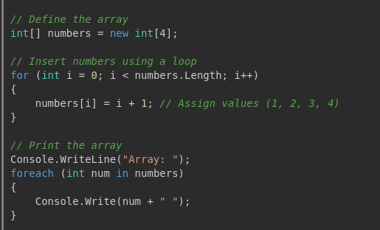

ii). ArrayList

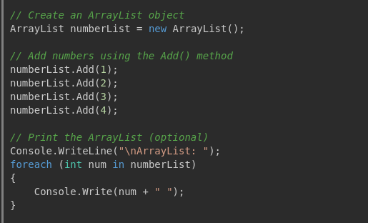
e)Differentiate between System.Text.StringBuilder class and System.String class

System.String: Immutable, less efficient for repeated modifications, suitable for simple operations, and provides a rich set of methods.

System.Text.StringBuilder: Mutable, more efficient for repeated modifications, suitable for complex string manipulations and performance-critical applications, with a focus on modification methods.

f)What is the output produced by the following program
